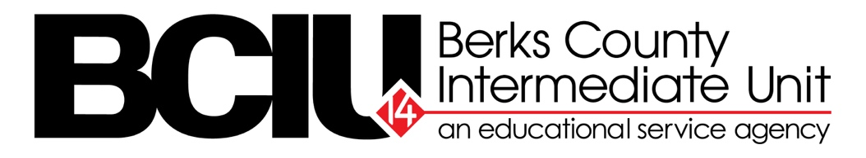

Berks County Intermediate Unit | Intranet Redesign

Throughout 2023, the Berks County Intermediate Unit worked to redesign their internal intranet website, also known as ‘BCIUnify’. The objective of the project was to create a simple and seamless site that serves as a relevant resource for the 1,200+ employees at the BCIU. It was also essential that the site supported communication, collaboration, and connection within the organization, as well as being mobile-friendly.

As this is an internal platform, there is no public URL. However, it should be noted that the new intranet contains many elements to make the site user-friendly, engaging, and useful for staff. Please view https://youtu.be/3C3TZj_sdaM for a virtual website walkthrough and an extensive overview of BCIUnify.

Below, please find before and after images of the BCIUnify Homepage:
BEFORE
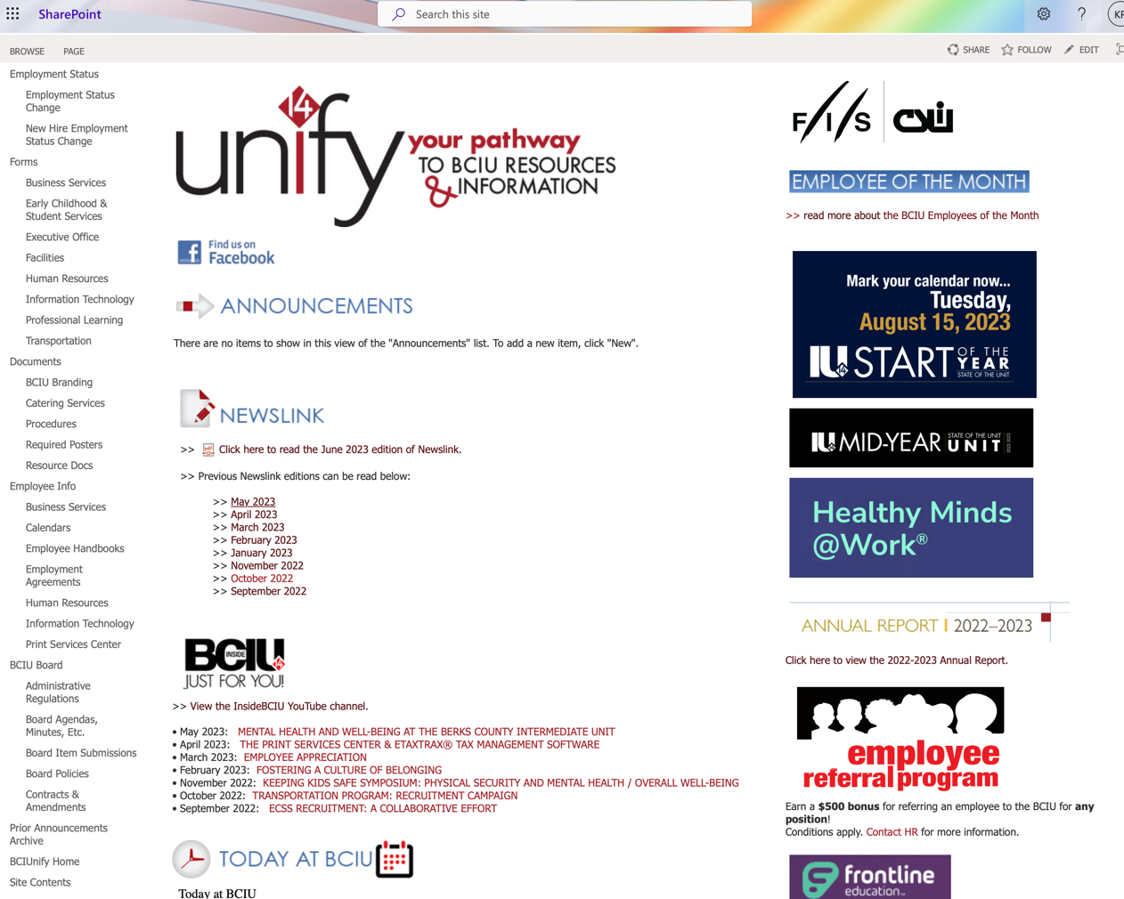
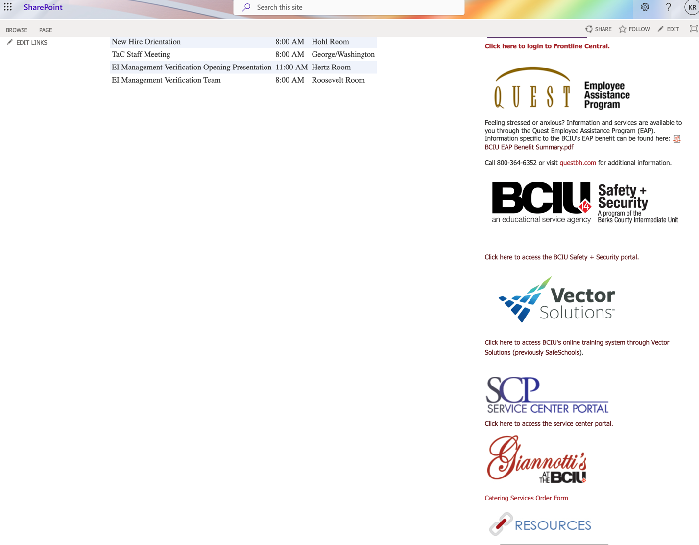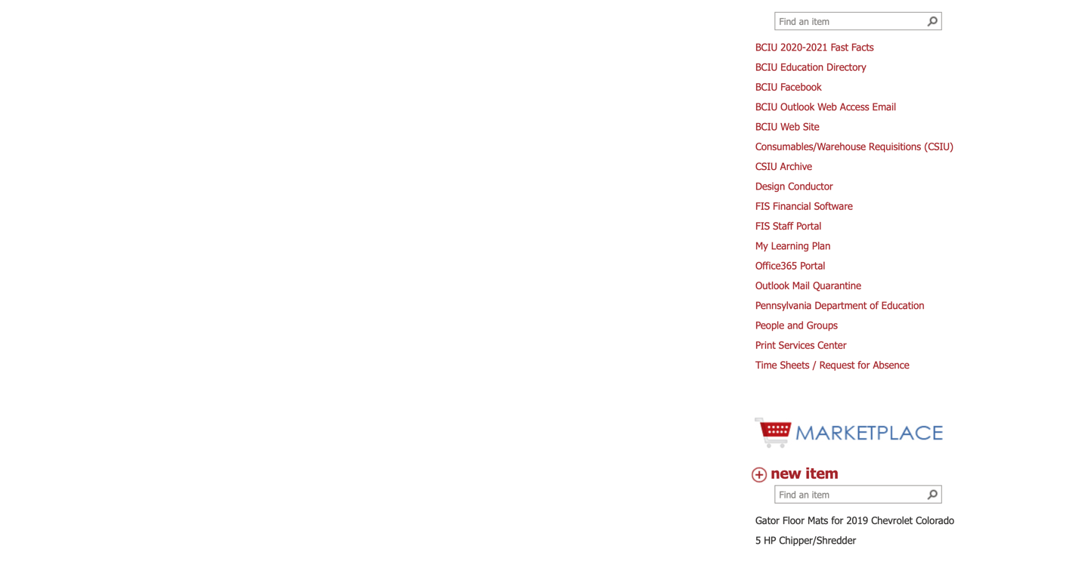
AFTER
